36.54: For bright spots, 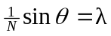
Red: 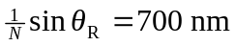
Violet: 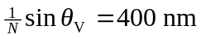
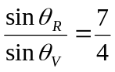
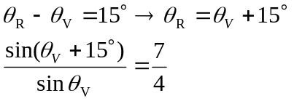
Expand: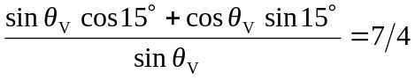
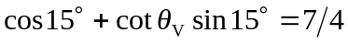
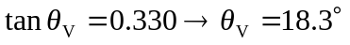

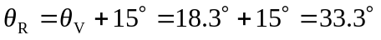

Line density: 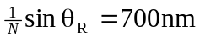
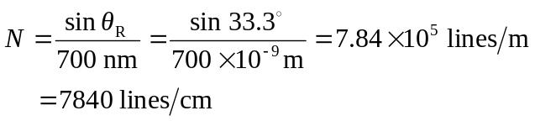
The spectrum begins at 18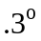and ends at 